S. KOLOKOLCHIKOV, Yu. SENICHEV

*Institute for Nuclear Research (Russian Academy of Science), Moscow, Russia*

**MAIN ARGUMENTS FOR CROSSING AND RAISING THE SYNCHROTRON TRANSITION ENERGY.**

The transition energy crossing requires special attention to preserve the stability of the beam during its acceleration to the energy of the experiment. Possible methods of the transition energy crossing in a synchrotron are considered as a case the NICA accelerator complex located in Dubna, Russia.

Keywords: transition energy, slip-factor, dynamic aperture, superperiod.

*Introduction*

This article is devoted to the research of methods of crossing and rising of transition energy in circular accelerator complexes during acceleration from injection to the final energy of experiment.

Transition Energy is an important characteristic of the synchrotron and depends only on the magneto-optical structure of the accelerator itself. At the same time, if no measures are taken, instabilities may develop in the synchrotron during transition energy passage. It can finally lead to the loss of the beam. To avoid this problem applies passage methods of transition energy both crossing and raising.

The first is a transition energy crossing method, it used widely in synchrotrons still nowadays. When the particle approaches unstable area the transition energy rapidly changes. To research this process, the dynamics of longitudinal motion should be studied taking into account the second order slip-factor as well as the influence of space charge effect. At the same time, it is necessary to monitor the change of the dynamic aperture in a wide range for the various crossing schemes considered. The crossing itself can be carried out by a rapid change in the gradient of quadrupole lenses located on the arcs of the synchrotron.

The second common method – creation a magneto-optical structure with a deliberately high transition energy value [2,3], thus, the need to pass the transition energy may disappear, since it will obviously be more than the energy of the experiment. So, all instabilities associated with particle movement near the transition energy do not arise at all. It is even possible to create a structure with a complex value of transition energy, with this approach, there will also be no passage of transition energy. Structures of such types were implemented on Moscow Kaon Factory (Russia) [4], SSC Booster (USA) [5], the neutrino factory in CERN (Switzerland) [6] and implemented in the accelerator complex J-PARC (Japan) [7]. This approach is also used for an antiproton storage ring in FAIR (Germany).

*Transition Energy*

With an increase of the particle’s energy in the synchrotron, both a change in the particle’s momentum and a change in the trajectory length occur.

In general, when determining, it is necessary to take into account the decomposition by degrees of momentum spread [8,9]:

When particle energy approaching the transition value of energy, the influence of the first term in expression (1) begins to be comparable with the second term. In this case – slip-factor defines as:

For the first two the most significant orders can be getting an expression:

*Passing Transition energy with a rapid jump*

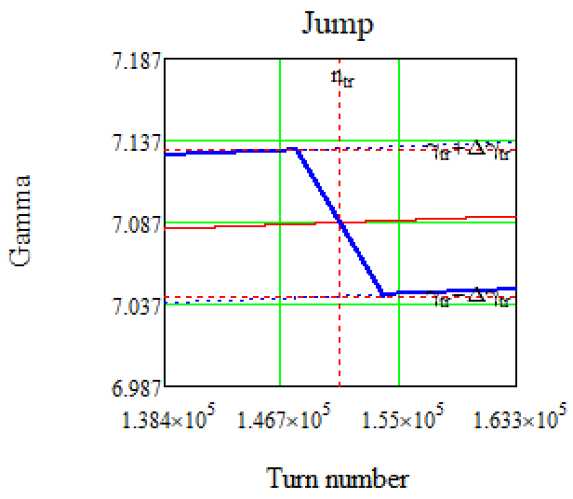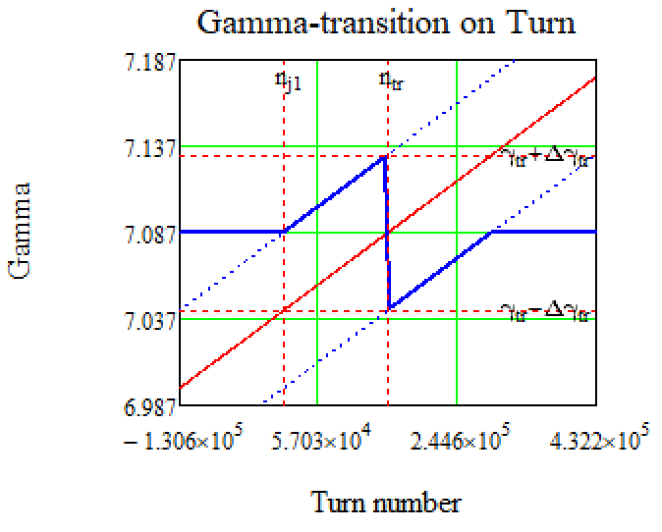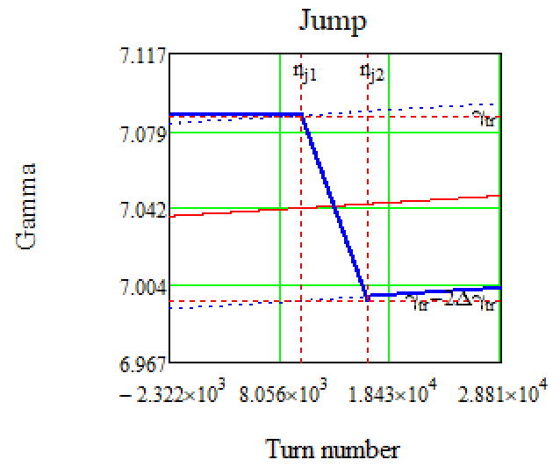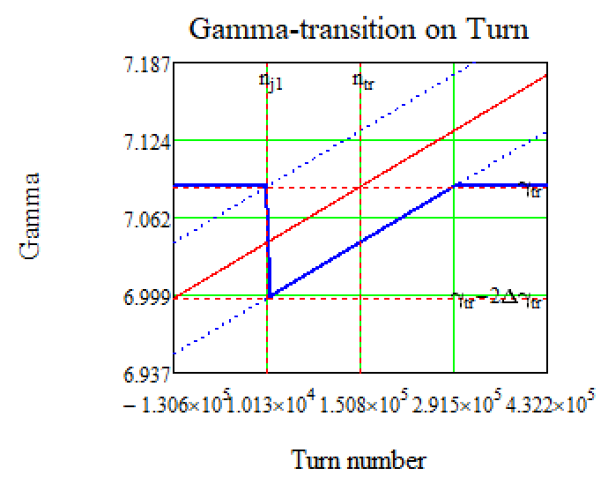 To minimize beam losses, a rapid change of transition energy is possible, it can be carried out by a rapid change of gradients in the quadrupole lenses of the arc. Thus, occurs a change of betatron tune of the whole synchrotron and it also changes a working point of the accelerator.

a) b)

Figure 1. Schematic diagrams of transition energy jumps.

Depending on the specifics of the choice of the working point of the accelerator, the method of performing a rapid change of the transition energy may also be different. On Figure 1 (a, b) schematic diagrams of crossing transition considered for the NICA collider are presented. These two options differ in which working points will need to be shifted during the jump. The dynamic aperture depends on the working point, which determines the stable area for the beam movement, this will be discussed in detail below.

Maximum rate of transition energy change limited by quadrupole parameters and its system __. For NICA collider it is possible to ___ characteristic values of growths rate of lenses field gradient , it is _____ to the rate of current growth . Rate of transition energy value change is , the time of the transition is .

Let’s consider a jump taking into account only the first order of the slip factor . Let's evaluate the value before the immediate jump, due to the symmetry with respect to zero, it will be equal to the value after transition (Pic. 3)

Equations of longitudinal motion in coordinates () is given by expressions [10,11]:

where – synchronous particle energy, – voltage generated by RF-barriers, , – harmonic number.

For modeling, in equations (12) it is convenient to switch from the time derivative to the turnover derivative : (also note that for protons )

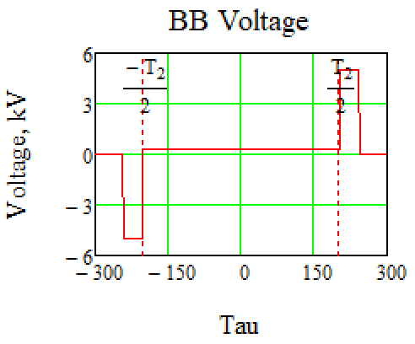As can be seen from equations (12, 13), the voltage generated by the RF barrier is important. In the NICA collider, the RF-1 system is used to retain, accumulate and accelerate particles to the experimental energy in the collider rings. Each collider ring has one RF-1 system. During retention and accumulation, 2 pairs of rectangular pulses with opposite signs are generated with the amplitude of each barrier (see Figure 7). The time duration of a single pulse can vary from . The accumulated particles enclosed between 2 pulses will be inductively accelerated by a constant potential , which is additionally created also by the RF-1 system [13].

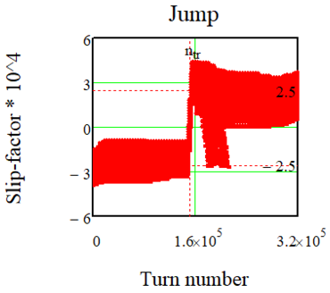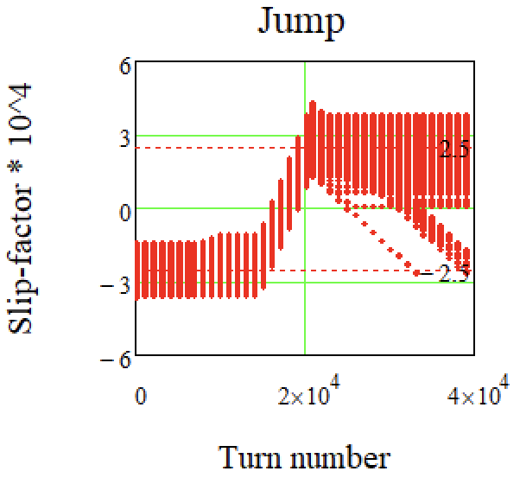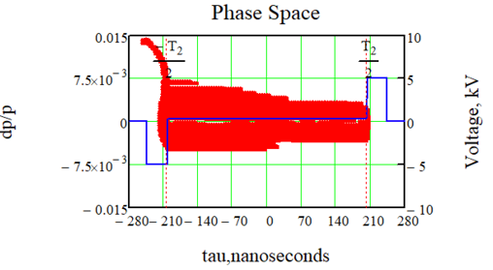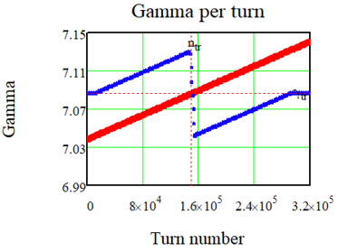When the energy approaches the transition value, the RF barriers turn off and, after the proton energy becomes greater than the critical energy, the RF barriers turn on and a polarity changes. This is necessary because the slip-factor value changes it’s sign after transition energy crossing. On the one hand, when the slip-factor is purely zero the system is isochronous and with any spread of momentum, the bunch does not increase the length. On the other hand, the following second order of slip-factor begins to play an essential role η, which distorts the movement and can lead to an increase in momentum spread. And finally, in the absence of focusing in the longitudinal plane, the space charge can introduce large distortions into the phase portrait of the bunch.

Figure 2. Voltage generated by a Barrier Bucket RF station.

Figure 3. Passage of transition energy with a jump, taking into account the second-order slip factor

a) Blurring of the phase plane in the RF barrier ; b) Transition enegry jump (blue dots), – gamma of particles (red dots); c) Jump of slip-factor for various particles; d) A more detailed scale of the jump.

As it can be seen on Figure 3 (c) there is a jump of slip-factor in a different time for different particles because of dependence of slip-factor on . Obviously, after the jump, particles with a negative value of the slip-factor will not be in a stable region, since the polarity of the retaining barriers changes and will tend to leave the phase plane, as it can be seen on Figure 3 (a, b). Also, due to the momentum spread, there is an asymmetry of the phase portrait relate to the zero value of the momentum spread .

When the working point changes, it is important to monitor the change of the dynamic aperture both before and after the jump. The change of the transition energy is possible due to a change in the frequency of betatron oscillations (tune) in the x-plane. It is achieved by changing the gradient of the focusing lenses in the collider arches. With the changed parameters of quadrupole lenses, the dynamic aperture was evaluated, it plays a main important role from the point of view of beam stability in the transverse plane. The corresponding calculations were carried out using OptiM and MADX programs.

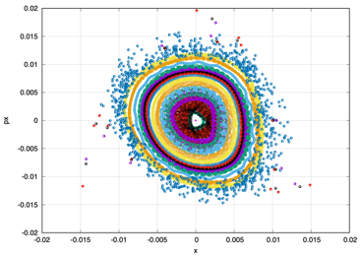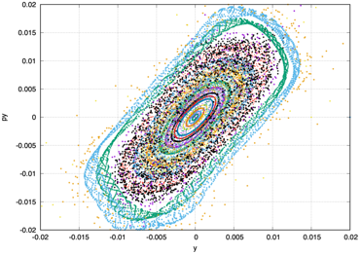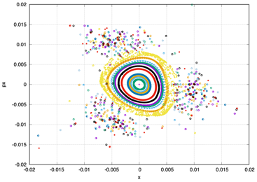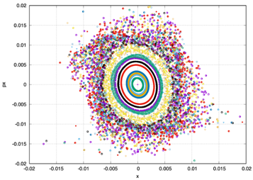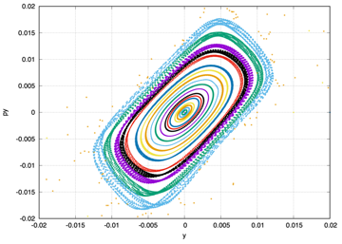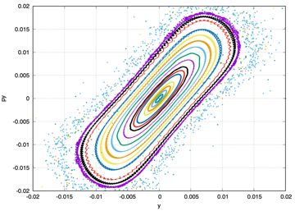 The results shown on Figure 4(a) indicate that the working point it is not suboptimal, since the dynamic aperture in the vertical plane is already initially small at these operating values. Moreover, if we assume the fact that it is necessary to reach the low frequency in the horizontal plane, with and in the vertical plane (see Figure 5). So thus, the transition energy is achieved , but the dynamic aperture in the horizontal plane disappears completely at these values of betatron tunes.

Thus we considered another option (see Figure 5): first, we gradually raise the transition energy to , then we make a rapid jump down to up to . In this case, the working point changes from up to the value before the jump (see Figure 4 b) and after the jump down to (see Figure 4 c).

Figure 4. Dynamic apertures (x–plane on the left, y–plane on the right) for different operating points at with suppressed natural chromaticity in the collider ring, taking into account the influence of the edge sextuple components of magnets and solenoids. On the abscissa axis is the coordinate in meters, on the ordinate axis is the relative momentum in radians.

## a) ; b) ;

## c)

*Метод создания магнитооптической структуры с высокой критической энергии*

This method differs in that it is necessary to make a change in the magneto-optical structure of the synchrotron itself. This is possible by introducing a special super periodic modulation of the gradients of quadrupole lenses on the arcs.

It can be seen from expression (9) that the value of the transition energy depends both on the dispersion function and on the function of the curvature of the orbit . The latter depends on the arrangement of dipole magnets. The dispersion function depends on quadrupole lenses and can be changed by introducing superperiodic modulation even in already created synchrotrons.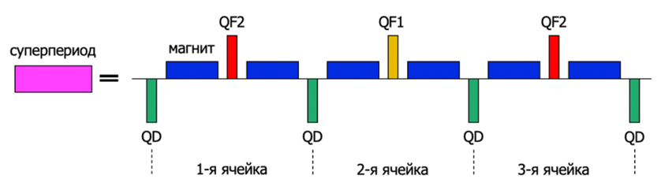 The superperiod is defined as a set of FODO cells as shown in Figure 5. As already mentioned, in the structure of NICA, the regular arrangement of deflecting magnets eliminates the possibility of modulation of the curvature of the orbit. Therefore, only the modulation of the force of quadrupole lenses along the length of the superperiod is used.

Рисунок 5. Принципиальная схема одного суперпериода, состоящего из 3-х ФОДО ячеек.

A resonant condition is realized for 12 FODO cells , , where , and 3 FODO cells are combined into one superperiod. Thus, tune of betatron oscillations is multiple 2π and the arcs has the properties of the first order achromat.

*Features of dispersion suppression*

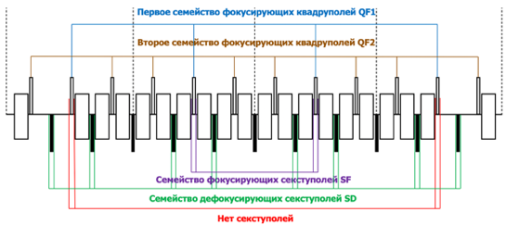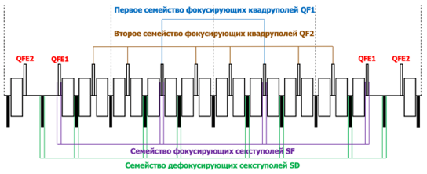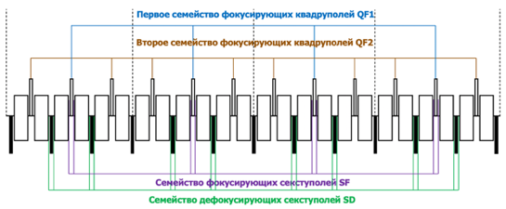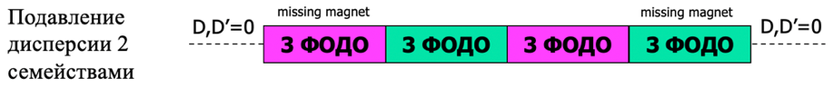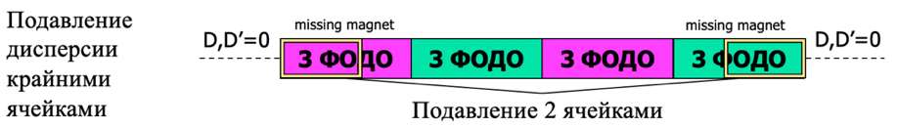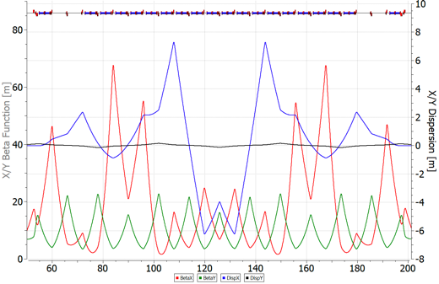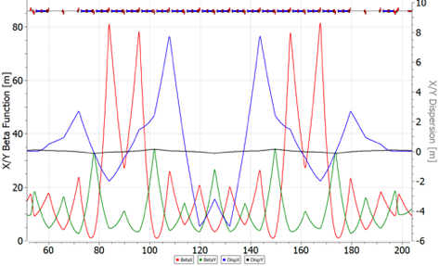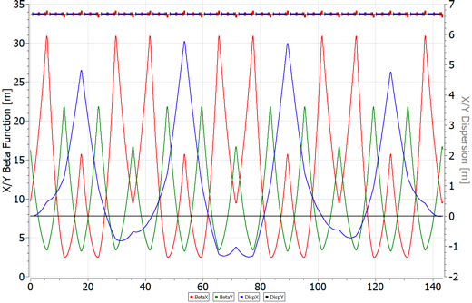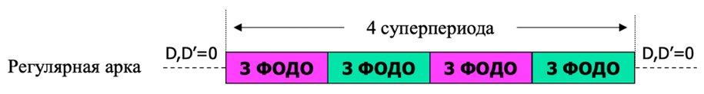To ensure the movement of particles along the equilibrium orbit of the synchrotron in rectilinear sections, it is necessary to ensure zero dispersion. This is easily implemented in the case of creating a completely regular arch. In Figure 6.1, the variance is suppressed automatically due to the choice of a multiple of π to the oscillation run on the arch and is an example of a first-order achromat. The arches do not always remain regular, this may be due, for example, to a feature of particle injection in the synchrotron ring, in which the missing magnet method is used when there is no dipole magnet in the FODO cell. In this case, an irregularity occurs due to the non-multiple π of the betatron oscillations, and there is a need for additional suppression of dispersion when exiting the arch. In this regard, different methods can be considered:

Figure 6. Schematic diagram of collider arcs for regular structures and structures with missing magnet. The arrangement of quadrupoles and sextupoles is given. Twiss functions with suppressed dispersion are also given.

1. Use edge cells for suppression (Figure 6.2) Suppression occurs using extreme superperiods. Namely, the two extreme FODO cells. (Edge Suppressor – ES). As can be seen, the two extreme FODO cells differ in the presence of missing-magnet and in these cells the quadrupoles QFE1 and QFE2 also have different gradients from the main quadrupoles of the arc and are selected in such a way as to suppress the variance.
2. Suppress using only two families of quadrupoles (Figure 6.3). This approach does not imply the presence of excellent quadrupoles, which simplifies both the arch itself, since only 2 families of quadrupoles are used, and power systems. However, in this case, due to the irregularity, it is impossible to ensure a raid of betatron oscillations on the arch of a multiple of π, in other words, it is impossible to create a first-order achromat.

*Chromaticity correction*

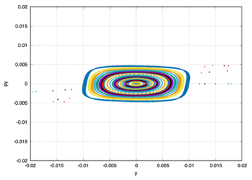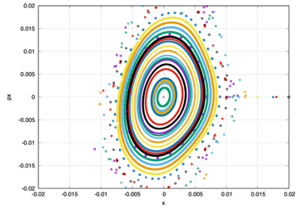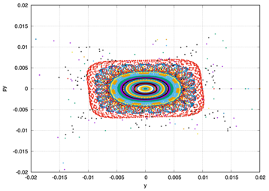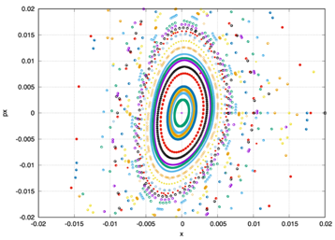Correcting sextupoles should first of all ensure the suppression of natural chromaticity caused by linear elements – quadrupoles and dipoles. To do this, sextupoles are installed in the region of non-zero dispersion on arcs near quadrupoles [13]. Sextupoles near focusing quadrupoles QF mainly affect , since the value of the beta function is greater in these places (similarly for defocusing ones). This means that chromaticity can be suppressed by only two families of SF and SD quadrupoles, located respectively next to the focusing and defocusing quadrupoles.

Figure 7. Dynamic apertures for various cases of dispersion suppression in a synchrotron. For .

When creating an arc with the first-order achromat property, with the correct arrangement of sextupoles, it is possible to achieve the creation of an arc with the second-order achromat property. This means that the mutual compensation of sextupoles will be performed. The creation of such an arch will ensure a high value of the dynamic aperture, since all nonlinear effects will be compensated.

The uncompensation of nonlinear effects can lead to the fact that the dynamic aperture will be suboptimal to ensure the area of stable beam motion. Figures 7 show dynamic apertures in both planes for different cases of dispersion suppression. It can be seen that the introduction of additional dispersion suppressors creates a significant nonlinearity (Figure 7 (a)) in comparison with the suppression of dispersion by only two families of quadrupoles. However, this requires a deeper modulation of the dispersion function and, accordingly, an increase in the value of the gradients of quadrupole lenses.

**Conclusion**

In this paper, the methods that have developed and are used in accelerator technology and can be used in the design of a synchrotron are considered. The problem of the passage of transition energy is associated with those instabilities that, due to various effects, can lead to the loss of the beam.

At method of passage using a rapid change in transition energy, the dynamics of longitudinal motion is investigated taking into account the second-order of the slip-factor. Due to the rapid jump of transition energy, the time at which the particles are near the zero value of the first-order slip-factor is significantly reduced. The method of raising the transition energy, also known as the method of creating a resonant magneto-optical structure, consists in deliberately raising the value of the transition energy above the energy of the experiment, or even achieving a complex value.

**References**

1. T.Risselada, Gamma Transition Jump Schemes, CERN-94-01, p 313.
2. Yu. V. Senichev and A. N. Chechenin. Construction of “Resonant” Magneto-Optical Lattices with Controlled Momentum Compaction Factor Journal of Experimental and Theoretical Physics, 2007, Vol. 105, No. 6, pp. 1141–1156.
3. Yu. V. Senichev and A. N. Chechenin. Theory of “Resonant” Lattices for Synchrotrons with Negative Momentum Compaction Factor. Journal of Experimental and Theoretical Physics, 2007, Vol. 105, No. 5, pp. 988–997
4. N. I. Golubeva, A. I. Iliev and Yu. V. Senichev, INR, Moscow, Nonlinear Dynamics in The Booster of The Moscow KAON Factory, IEEE 1991.
5. E.D.Courant, A.A.Garren, U.Wienands, Low Momentum Compaction Lattice Study For The SSC Low Energy Booster, PAC 1991.
6. B. Autin, R. Cappi, J. Gareyte, R. Garoby, M. Giovannozzi, H. Haseroth, M. Martini, E. Métral, W. Pirkl, H. Schönauer, CERN, Geneva, Switzerland, C.R. Prior, G.H. Rees, RAL, Chilton, Didcot, U.K., I. Hofmann, GSI, Darmstadt, Yu. Senichev, FZJ, Jülich, Germany, A Slow-Cycling Proton Driver for A Neutrino Factory, Proceedings, 7th European Conference, EPAC 2000, Vienna, Austria, June 26-30, 2000. Vol. 1-3
7. Y.Mori, Y.Ishi, M.Muto, H.Nakayama, C.Ohmori, S.Shibuya, T.Tanabe, M.Tomizawa, INS University of Tokyo, Synchrotron Design Issues Of The Japanise Hadron Project, EPAC 96.
8. K. Y. Ng. Physics of Intensity Dependent Beam Instabilities, Fermilab-FN-0713, 2002
9. J.L. Laclare, ESRF, Grenoble, France. Coasting Beam Longitudinal Coherent Instabilities, CAS - CERN Accelerator School: 5th General Accelerator Physics Course.
10. J. Wei and S. Y. Lee. Space Charge Effect at Transition Energy and The Transfer of R.F. System at Top Energy, BNL–41667
11. Hans Stockhorst, Takeshi Katayama, Rudolf Maier. Beam Cooling at COSY and HESR Theory and Simulation – Part 1 Theory. Forschungszentrum Jülich GmbH Zentralbibliothek, Verlag Jülich. ISBN 978-3-95806-127-9(2016) p161-171.
12. A. Verdier, CERN, Geneva. Chromaticity. CAS - CERN Accelerator School: 5th General Accelerator Physics Course.
13. Syresin, E. M., Butenko, A. V., Zenkevich, P. R., Kolokolchikov, S. D., Kostromin, S. A., Meshkov, I. N., Mityanina, N. V., Senichev, Y. V., Sidorin, A. O., & Trubnikov, G. V. (2021). Formation of Polarized Proton Beams in the NICA Collider-Accelerator Complex. Physics of Particles and Nuclei, 52(5), 997-1017. <https://doi.org/10.1134/S1063779621050051> p22-26